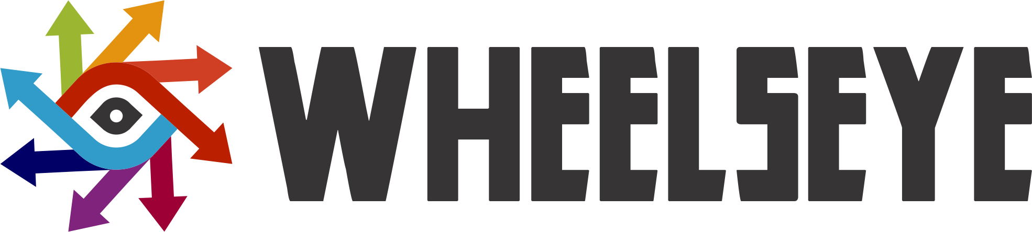

**Please include a URL for your online portfolio in addition to your resume. Submissions without a portfolio included will not be considered.**

Design and user experience (UX) are at the forefront of everything we do. The job of a Designer is to envision how people experience our products and bring that vision to life in a way that feels inspired, refined and even magical. In a Designer role, you’ll take on complex tasks and transform them into intuitive, accessible and easy-to-use solutions for our customers — from the first-time user to the sophisticated expert.

Achieving this goal requires collaboration with teams of other Designers, Researchers, Engineers and Product Managers throughout the design process—from creating user flows and wireframes to building user interface mockups and prototypes. At each stage, you will anticipate what our users need, advocate for them and ensure that the final product surprises and delights them.

One of the many reasons Wheelseye consistently brings innovative, world-changing products to market is because of the collaborative work we do in Product Management. With eyes focused squarely on the future, our team works closely with creative and prolific engineers to help design and develop technologies that improve access to the world's information. We're responsible for guiding products throughout the execution cycle, focusing specifically on analyzing, positioning, packaging, promoting and tailoring our solutions to all the markets where Wheelseye does business.

At Wheelseye, we leave all egos at the door and concentrate on the job at hand. We value passionate, down to earth, “can do” people who enjoy fine-tuning small details, without losing sight of the big picture. We are looking for the type of person who feels uncomfortable when a day goes by without achieving something impactful.

**Responsibilities**

* Lead design projects across the entire product lifecycle and multiple product launches
* Work with small multi-disciplinary teams. You’ll partner closely with engineering, product, and business folks to find elegant but practical solutions to design challenges
* Be autonomous. You’ll take full ownership of your work, and you take responsibility for every last detail, every step of the way
* Rapidly produce multiple concepts and prototypes; knowing when to apply pixel-perfect attention to detail, and when to make low-fi sketches and prototypes, Design for screens and web interfaces

**Visual Design Related:**

* Produce quality design that accurately reflect a visual design language or brand guideline.
* Understand of typography, color, grid, and composition. Demonstrate best practices for pixel-perfect production considerations and methods.
* Use a broad range of style that can be consistently executed with an aesthetic personality or voice that is consistent, though not restricting.
* Develop and communicate underlying concepts that inspire design implementation.

**Interaction Design Related:**

* Produce and test interaction flows and mocks that accurately communicate product functionality to product, engineering, and visual design team members.
* Pair research with an intellectual curiosity that encourages testing and iteration is essential.
* Understand modern web and/or mobile environments such as HTML, CSS, JavaScript, Android UI, and iOS UI, as well as how the technologies of each can be used to further enhance the overall experience.
* Appreciate aesthetic details.

**Motion Design (Good to have but not Mandatory):**

* Create motion studies for enhancing usability, interaction, storytelling and delight.
* Work closely with UX partners and product managers to ideate and define.
* Work closely with engineering to integrate into products.
* Work closely with research to test and inform user experiences.

**Who Can Apply**

* Experience and working knowledge of Photoshop, CorelDraw or Illustrator
* Relevant experience in design. Remember this role requires UX and Visual design skills but not limited to these
* Must have a passion for designing and an ownership attitude towards work
* Biased toward action and execution. You get nervous if you’re not sketching concepts, tweaking flows or polishing the designs that represent the big-thinking work
* Great communication skills that help you work with product and engineering to make product visions come to life
* Constantly looking to hone your design instinct through user feedback. Whether through hands-on user research, or by designing options for an A/B test
* Ability to apply brand visual assets in a user interface context and understanding of user-centered design principles.
* Solid analytical, creative and visual thinker with excellent communication skills, both verbal and visual.
* Strong design background in fundamentals along with relevant internship work, work experience, or personal project experience outside the classroom in interaction, graphic design or motion design.

**Remuneration**

* INR 6,00,000 - INR 12,00,000 Annual

**About Company**

Wheelseye offers technology to empower truckers. Our software helps save costs, build safe and secure infrastructure, automate operations and streamline your business. We provide end to end technology backend from basic things like GPS live location tracking to complex tasks like driving profitability and automation in your business.

Our Software as a Service enables data driven decision making by reading a number of connected devices. We give highest priority to security and safety of your infrastructure & data. Our platform is fully customizable and can be tailored as per the needs of your business and targets.

We are a young and energetic team of IIT graduates having rich industry and technology experience. Our mission to become the preferred technology partner to our business partners. It is our constant endeavour to constantly create and evolve data-driven software solutions that conquer business problems and inspire smarter decisions.

For more info, please write to Sonesh on [connect@wheelseye.com](mailto:connect@wheelseye.com)